In system analysis, use case diagrams and sequence diagrams play critical roles in modeling system interactions and functionalities. These diagrams help communicate the system’s requirements, user interactions, and data flow.

For a Sponsorship Management System, where key actors are the Admin, Sponsor, and Sponsee (beneficiary), these diagrams are crucial to capture the relationship between these actors and the system.

As elaborated bellow

**Use Case Diagrams in Sponsorship Management System**

use case diagram provides a high-level overview of the system’s functional requirements, outlining how the system's actors that is Admin, Sponsor, and Sponsee interact to achieve specific goals. In a Sponsorship Management System, these three actors are central to the functioning of the system.

**The following are the roles or actions for each actor**

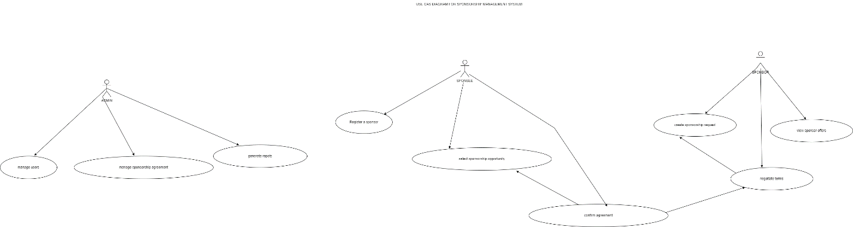

**A: Admin**

Manage Users. The Admin adds, edits, or removes users for example Sponsors and Sponsees from the system.

Also Manage Sponsorship Agreements. The Admin can oversee sponsorships, ensuring that terms are properly recorded and adhered to by both Sponsors and Sponsees.

Generate Reports. The Admin generates system-wide reports on sponsorship performance and user activities.

**B: Sponsor**

Register as Sponsor. The Sponsor can register in the system by submitting required details such as organization name, contact information, and sponsorship preferences.

Select Sponsorship Opportunities. The Sponsor browses available sponsorship opportunities and selects those that align with their goals.

Confirm Agreement. The Sponsor confirms the sponsorship terms and agreement with the Sponsee and Admin, ensuring that expectations are clear.

**C: Sponsee (Beneficiary)**

Create Sponsorship Request. The Sponsee submits a request for sponsorship for a specific event or project, detailing their needs and expectations.

Sponsor Offers. Once the request is submitted, the Sponsee can view sponsorship offers from Sponsors who express interest.

Negotiate Terms. The Sponsee may negotiate the sponsorship terms with the Sponsor to meet mutual expectations before the Admin approves it.

**Sequence Diagrams in Sponsorship Management System**

A sequence diagram illustrates the dynamic flow of interactions over time between the Admin, Sponsor, and Sponsee. This helps depict how a specific use case plays out.

For example, Sponsorship Agreement Process

For the Sponsorship Agreement Process, the sequence diagram would illustrate how the Admin, Sponsor, and Sponsee interact to finalize a sponsorship. The sequence might unfold as follows:

1.Sponsee submits a sponsorship request to the system, detailing the event/project.

2. Admin reviews and approves the request, making it available to potential Sponsors.

3. Sponsor logs into the system, browses available sponsorship opportunities, and selects the Sponsee’s request.

4. System sends the Sponsee a notification of the Sponsor's interest.

5. Sponsee reviews the Sponsor's proposal and negotiates the terms if necessary.

6. Sponsor confirms the sponsorship agreement after negotiation.

7. Admin approves the finalized agreement and updates the system.

8. System notifies both the Sponsor and Sponsee of the finalized agreement.

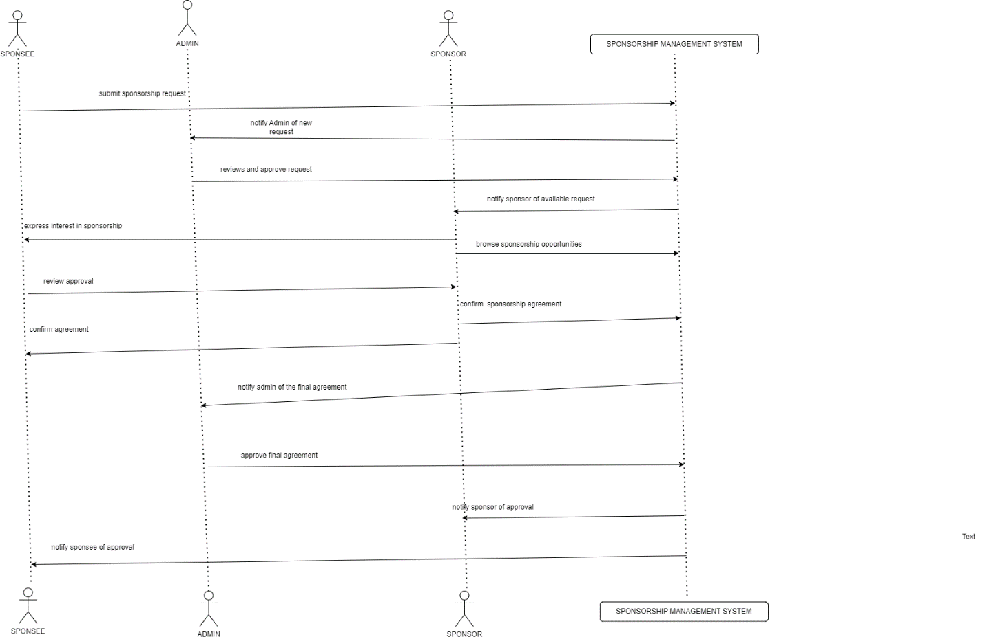

This sequence diagram highlights the step-by-step process, showing how the three actors interact and exchange information to complete the sponsorship agreement. It provides a clear picture of the flow of data, decisions, and actions within the system, making it easy for developers and analysts to understand the temporal nature of interactions.

**Importance of Use Case and Sequence Diagrams in System Analysis.**

1. Clarity of Requirements. Use case diagrams ensure that each actor's role and functionalities are clear, simplifying communication between developers and stakeholders.

2. Identification of Key Actors and Processes. By mapping out use cases, the diagram ensures that important interactions like sponsorship agreements, report generation, and user management are fully understood.

3. Visualization of Process Flow Sequence diagrams provide a temporal view, which helps analysts visualize the system’s behavior and the step-by-step interactions between actors, improving the system’s design and flow.

4. Enhanced Communication and Documentation. Both diagrams act as vital documentation tools for future development and system improvements, offering a shared understanding of how the system operates.

5. Facilitation of Testing. These diagrams are useful for validating system functionality. The sequence diagram, in particular, helps identify whether the system responds appropriately to inputs from different actors.

**Class Diagram for Sponsorship Management System**

A class diagram for the Sponsorship Management System represents the system's structure by showing the system's classes, their attributes, and relationships between them.

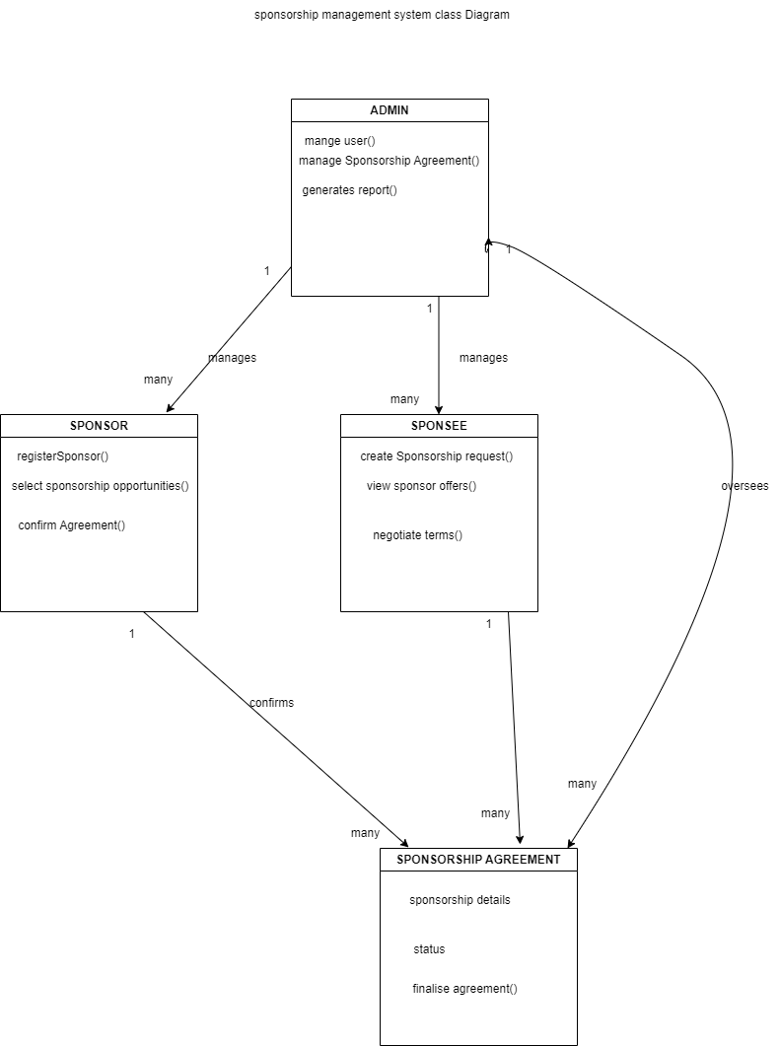

1. Sponsor. Represents sponsors (companies or individuals) providing funds or resources.

Relationships

A sponsor can have multiple sponsorships (One-to-Many with `Sponsorship`).

2. Sponsorship Represents an agreement between a sponsor and a sponsored entity/event.

Relationships

Linked to a single sponsor (Many-to-One with Sponsor).

Can sponsor multiple events (Many-to-Many with Event).

3. Event Represents the event or project being sponsored.

Relationships

Can be sponsored by multiple sponsorships (Many-to-Many with Sponsorship).

Linked to sponsored entities (One-to-Many with Sponsored Entity).

4. Sponsored Entity Represents the person, team, or organization receiving sponsorship.

Relationships

Can receive multiple sponsorships (One-to-Many with `Sponsorship`).

5 Contract Represents the legal agreement for a sponsorship.

Relationships

Linked to one sponsorship (Many-to-One with `Sponsorship`).

6. Payment Represents financial transactions in relation to a sponsorship.

Relationships

Linked to one sponsorship (Many-to-One with `Sponsorship`).

7. User (Admin) Represents the users managing the system.

Relationships

Can manage multiple events and sponsorships (One-to-Many with Event and Sponsorship).

Relationships:

**One-to-Many**, A sponsor can sponsor multiple sponsorships, a sponsorship can have multiple payments and contracts, and a user can manage multiple sponsorships and events.

**Many-to-Many**, Events can have multiple sponsors, and sponsors can sponsor multiple events (using a many-to-many relationship through sponsorships).

Inclusion use case and sequence diagrams are tools in the system analysis of a Sponsorship Management System and provides a high-level view of interactions between the Admin, Sponsor, and Sponsee and whereas sequence diagram illustrates the step-by-step process of specific interactions such as sponsorship agreements.